NLP Workshop 6

Top 10 words in each topic using LDA model

* Topic 1: rain cup farmers nsw water police qld north boost play
* Topic 2: man govt police nsw missing court claim search melbourne probe
* Topic 3: new govt war dead union coast claims gold vic anti
* Topic 4: says mp death set china court man nsw toll face
* Topic 5: iraq police council murder says pm water man plan war

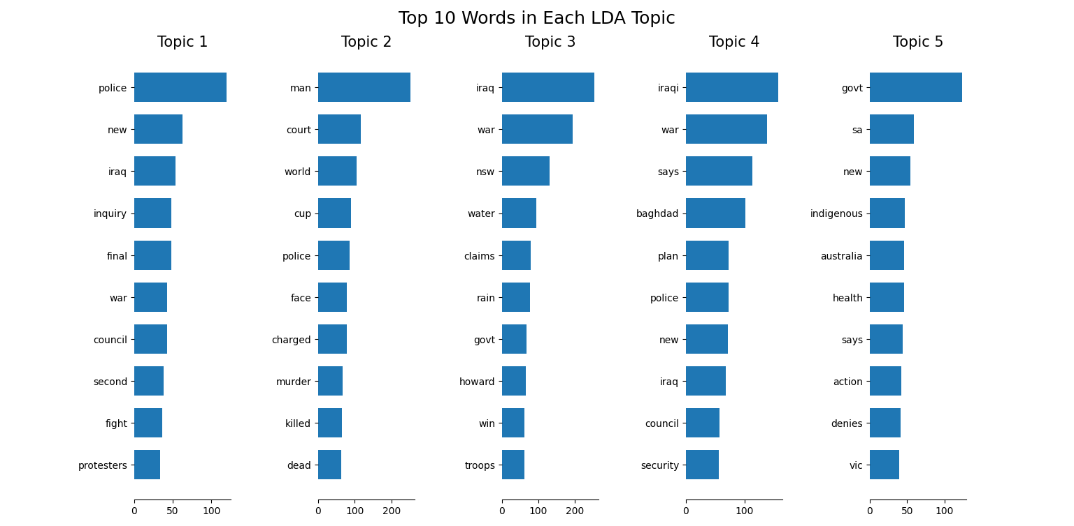

Top 10 words in each topic using LSA model

* Topic 1: rain cup farmers nsw water police qld north boost play
* Topic 2: man govt police nsw missing court claim search melbourne probe
* Topic 3: new govt war dead union coast claims gold vic anti
* Topic 4: says mp death set china court man nsw toll face
* Topic 5: iraq police council murder says pm water man plan war

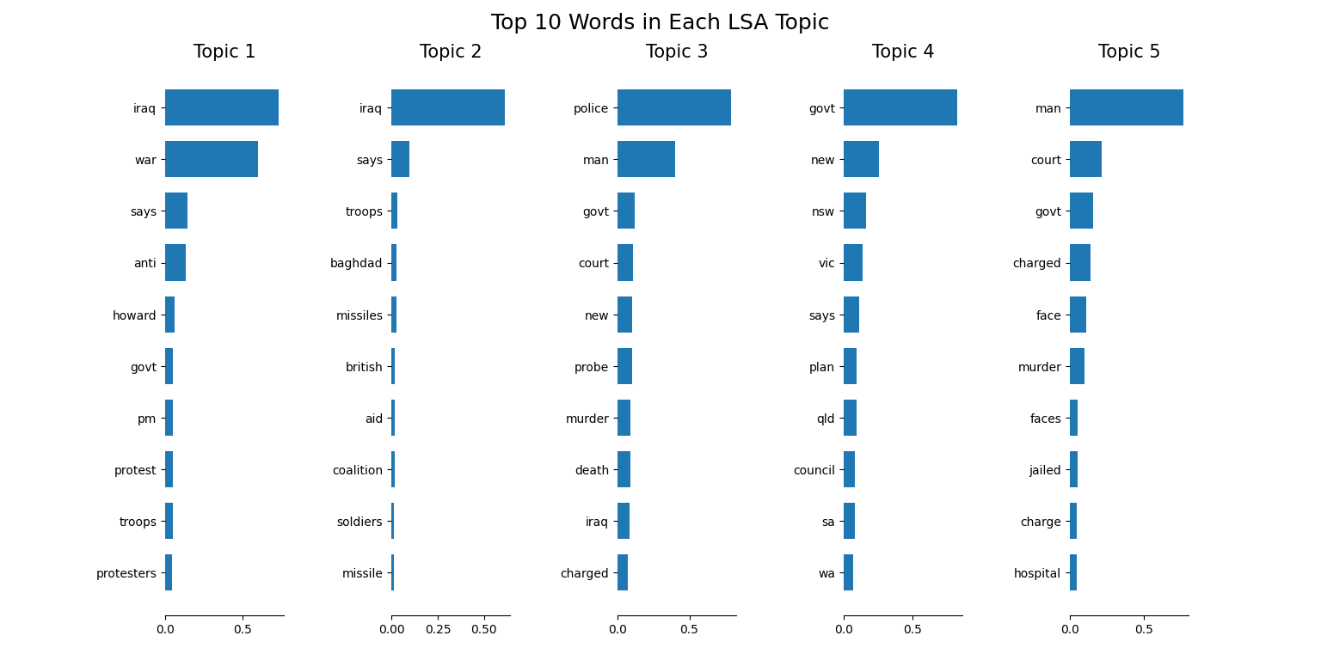

By eye bawling, I think both of the model perform pretty well, but by looking at the graph I think LDA performs a bit better because the topic is more diverse.